Iterium Documentation

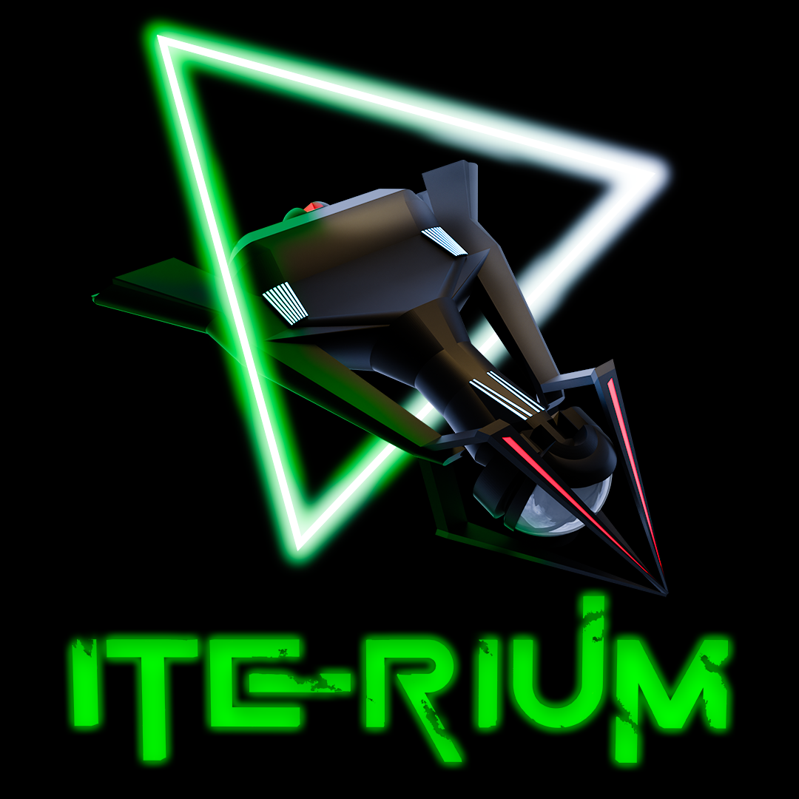

Revision: 1

Table of Contents

1. Game Overview 4

1.1. Game Story 5

1.2. Factions and ships 5

1.3. Controls 5

1.4 Scoring & Levels 6

1.5. Upgrading 6

1.6. Screenshots 7

1.6.1. Main Menu 7

1.6.2. Faction Selection 7

1.6.3. Game 8

1.6.4. Upgrades 8

1.6.5. High Score 9

1.6.6. Tutorial 10

1.6.7. Player Profile 10

1.6.8. Settings 11

1.6.9. Game Over 11

2. Unity Project 12

2.1. Project requirements 12

2.2. Folder Structure 12

2.3. Classes & Assemblies 14

2.4. Save System 16

2.4.1. Save files and methods 16

2.4.2. Path 16

2.4.3. Player data 16

2.4.4. Leaderboard data 16

2.4.5. File save handler 17

2.5. ScriptableObjects 18

2.5.1. SO_Leaderboard 18

2.5.2. SO_Player 18

2.5.3. SO_FactionList 18

2.5.4. SO_Faction 18

2.5.5. SO_Ship 19

2.5.6. SO_Bullet 19

2.5.7. SO_SFX 19

2.6. Managers 20

2.6.1. Singleton 20

2.6.2. GameManager 20

2.6.3. SoundManager 24

2.6.4. Bullet Pooling 25

2.6.5. Asteroid Pooling 25

2.6.6. Explosion Pooling 26

2.6.7. Input Manager 26

**2.6.7.1.** **Input Actions – Input System** 27

2.8. Gameplay Scripts 28

2.8.1. PlayerContoller 28

2.8.2. AIContoller 29

2.8.3. NPCContoller 31

2.8.4. BossController 31

2.8.5. BulletBase 32

2.8.6. BulletBase 32

2.8.7. Bullet 33

2.8.8. BulletAI 33

2.8.9. BulletNpc 33

2.8.10. Iterium 34

2.7.9. Asteroid 34

2.8. User Interface 35

2.8.1. Unity Style Sheets 35

2.8.2. UI Toolkit Documents 36

2.8.3. UI Scripts 36

2.9. Spawning 42

2.10. Plugins 43

2.11. Builds 44

# Game Overview

|  |  |
| --- | --- |
| Genre | Top-down space shooter |
| Theme | 1980s Arcade |
| Perspective | 2.5D |
| Game engine | Unity (version 2021.3.15f1) |
| Scripting language | C# |
| Build targets | WebGL – Desktop browsers |
| License | GNU General Public License v3.0 – See here |
| Gameplay | The game follows a typical arcade genre where you try and survive as long as possible to gain the highest score and be entered on the leaderboard. Score can be achieved by shooting asteroids, collecting Iterium crystals, killing AI ships and Xoid flying Saucers.    At the start of the arena battle you will receive 3 ships (lives) and the battle will end when you lose all your lives. Asteroids do not do damage to your ship but will push your ship from course depending on the weight of the selected ship and size of the asteroid. Enemy fire can be destroyed with your own fire and damage can be reduced by deploying your shield.  When you or the AI are destroyed, a re-spawn delay will provide a short reprieve to the opponent to collect any floating crystals and rack up further points.    Iterium crystals are dropped randomly by destroying asteroids, crystals are used to upgrade the firepower, shield, and speed of your spaceship. Picking up crystals before your opponent is crucial to prevent them from also upgrading, increasing your maneuverability, offensive and defensive capabilities will give you the edge in battle.    There are 3 faction ships to choose from, each having their own balance of firepower, shields and speed. Each of the ship properties can be upgraded twice, the USSR Hammer is the heaviest ship and will be less impacted by asteroids while the lightest Chinese Rapier, although the fastest ship will struggle against flying debris. Each of the ship’s statistics can be viewed on the faction selection screen, including the status after upgrading. |

## Game Story

You are a space miner in the year 2055, traveling through the galaxy in search of rare and valuable Iterium crystals. These crystals are a crucial source of energy for space travel by an alien race called Xoids, and the demand for them is skyrocketing. Your goal is to collect as many of these crystals as you can and become the richest space miner in the galaxy.

As you travel from planet to planet, you hear rumors of a large asteroid belt rich in Iterium crystals. With excitement, you set your course for the belt and begin your search. The asteroids are treacherous, filled with danger at every turn, but the reward is worth the risk.

You equip your mining ship with the latest technology, including offensive weaponry with enough firepower to split asteroids. With each successful mining mission, your ship fills with Iterium crystals, but your journey is far from over. As you delve deeper into the asteroid belt, you encounter rival miners and Xoid UFOs who will stop at nothing to steal your valuable cargo. You must defend yourself and your ship from their attacks, using your maneuverability, firepower, and shields to fend them off.

You are determined to come out on top of the leaderboard, collecting as many crystals as you can and earning a place in the annals of space mining history. Will you become the richest space miner in the galaxy, or will you be defeated by the dangers of the asteroid belt? The fate of your journey rests in your hands.

## Factions and ships

The Sword belongs to the USA faction and is the most balanced of the 3 ships. The ships most impressive feature is its firepower, medium thrust capabilities with its shields being its weakest feature. Good balance of attack and maneuverability when fully upgraded. Weight is in the medium range and impacts how you are affected by the weight of an opposing asteroid.

The Hammer is the pride of the USSR faction and is built like a tank, very slow in maneuverability but makes up for it with its superb shields and medium fire power capabilities. A good ship for attack and defense during heated battles when fully upgraded. Heaviest weight of all the ships, impacts how you are affected by the weight of an opposing asteroid.  
  
The Rapier belongs to the Chinese faction, is sleek in design with blazingly fast thrusters. Firepower is the weakest of all ships with a medium shield capability. A good ship to avoid attack and quick Iterium collection. The lightest ship which impacts how you are affected by the weight of an opposing asteroid.

## Controls

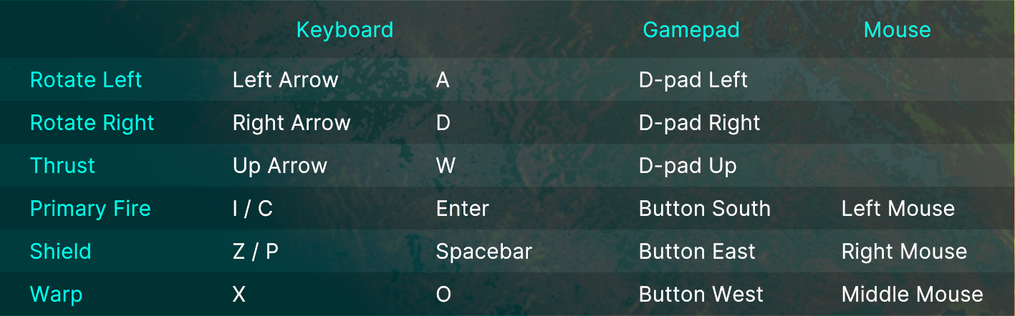

## 1.4 Scoring & Levels

Destroying NPC

Score + 1500

XP + 100

Hitting an AI Player

Score + 500

XP + 50

Hitting a Boss

Score + 800

XP + 25

Hitting an Asteroid

Score + 50

XP + 10

Collecting Iterium

Score + 250

XP + 25

Points Bonus (Game Over scene)

At the end of each battle, you will receive a points bonus calculated as (Iterium collected x 100) x level.

Leveling

Every 20000 XP gained.

## Upgrading

Upgrades are split into 3 different categories that can be upgraded twice each:

* Thrust
* Shields
* Firepower

You will need the required amount of Iterium indicated by each category slider on the upgrade screen. Iterium is dropped by destroying asteroids, there is a 20:1 chance of a drop.



## Screenshots

### Main Menu

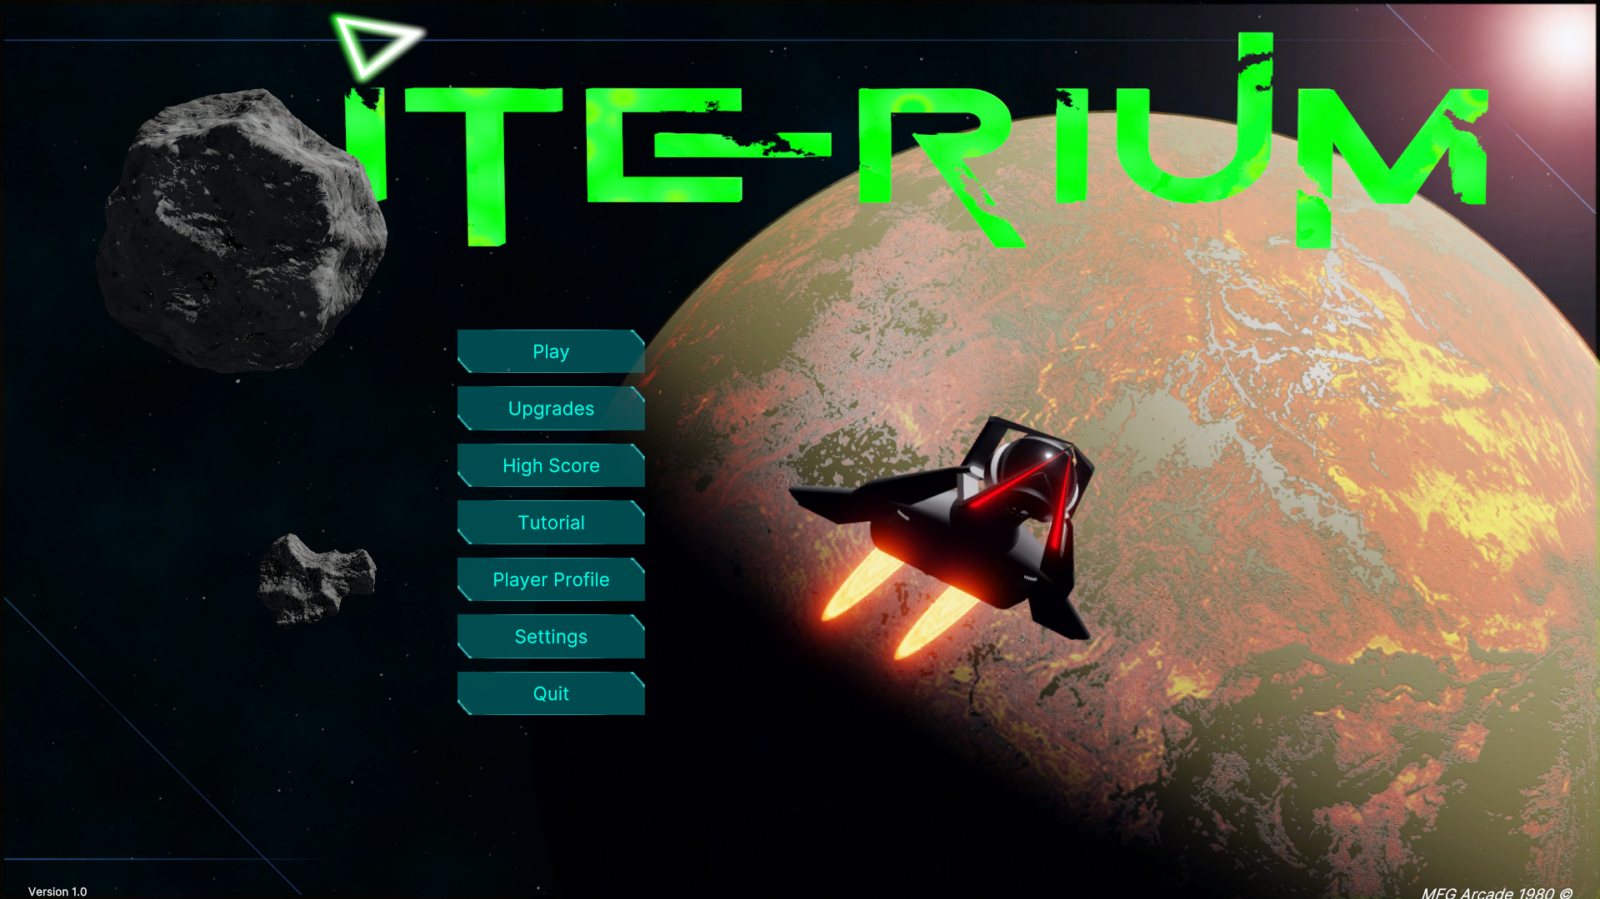

### Faction Selection

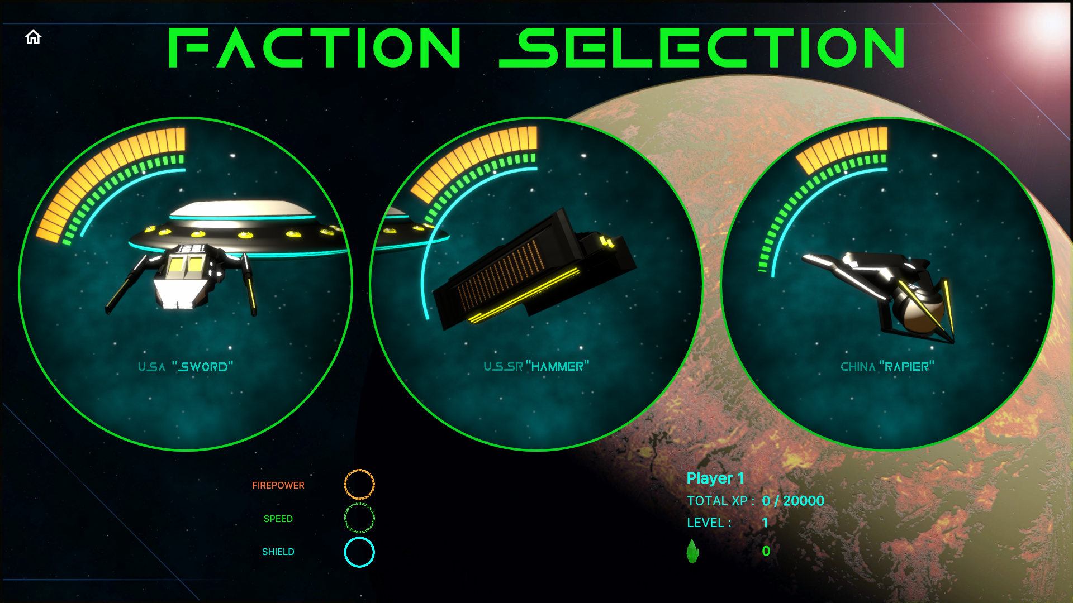

### Game

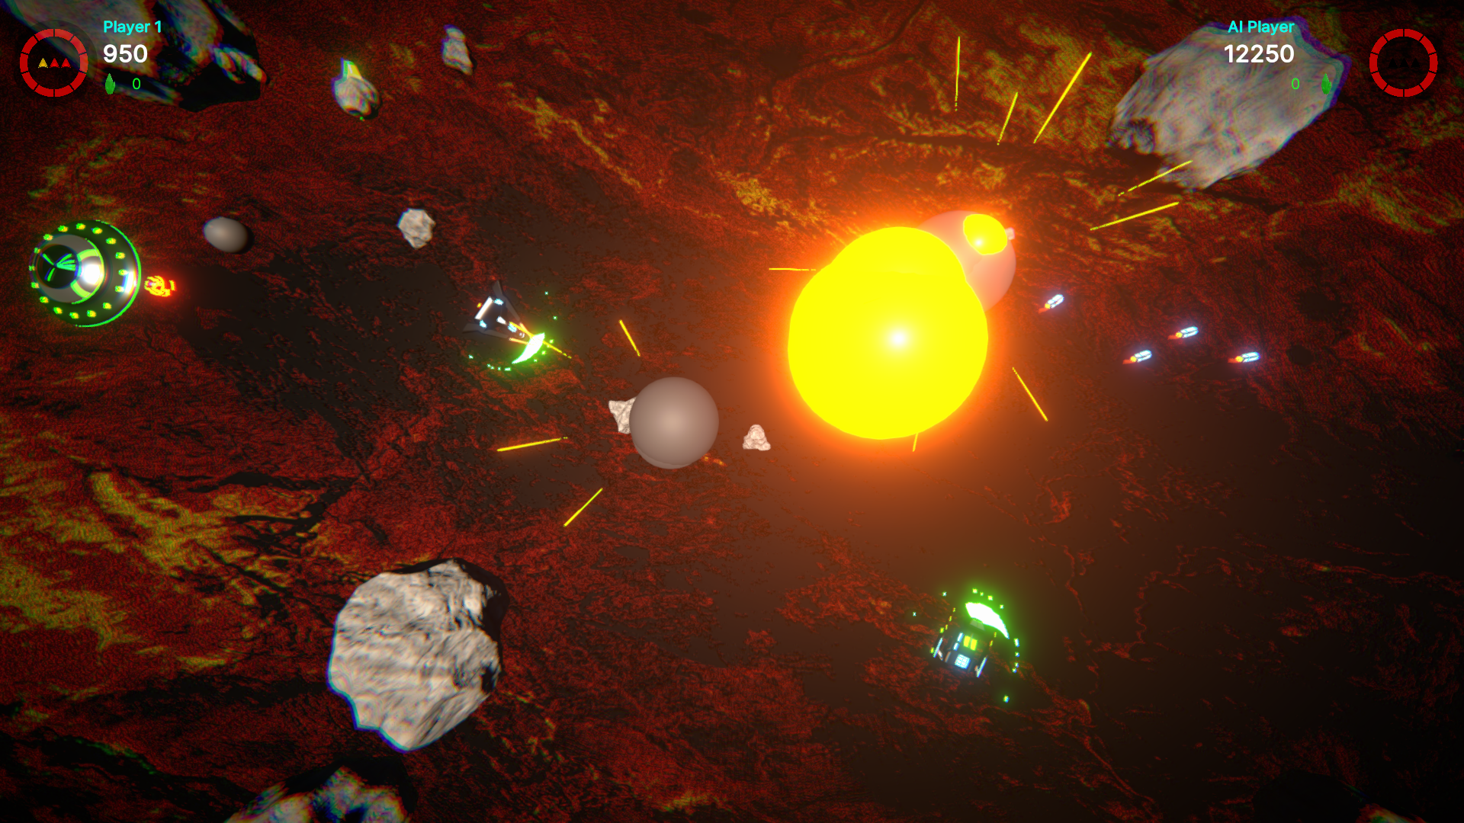

### Upgrades

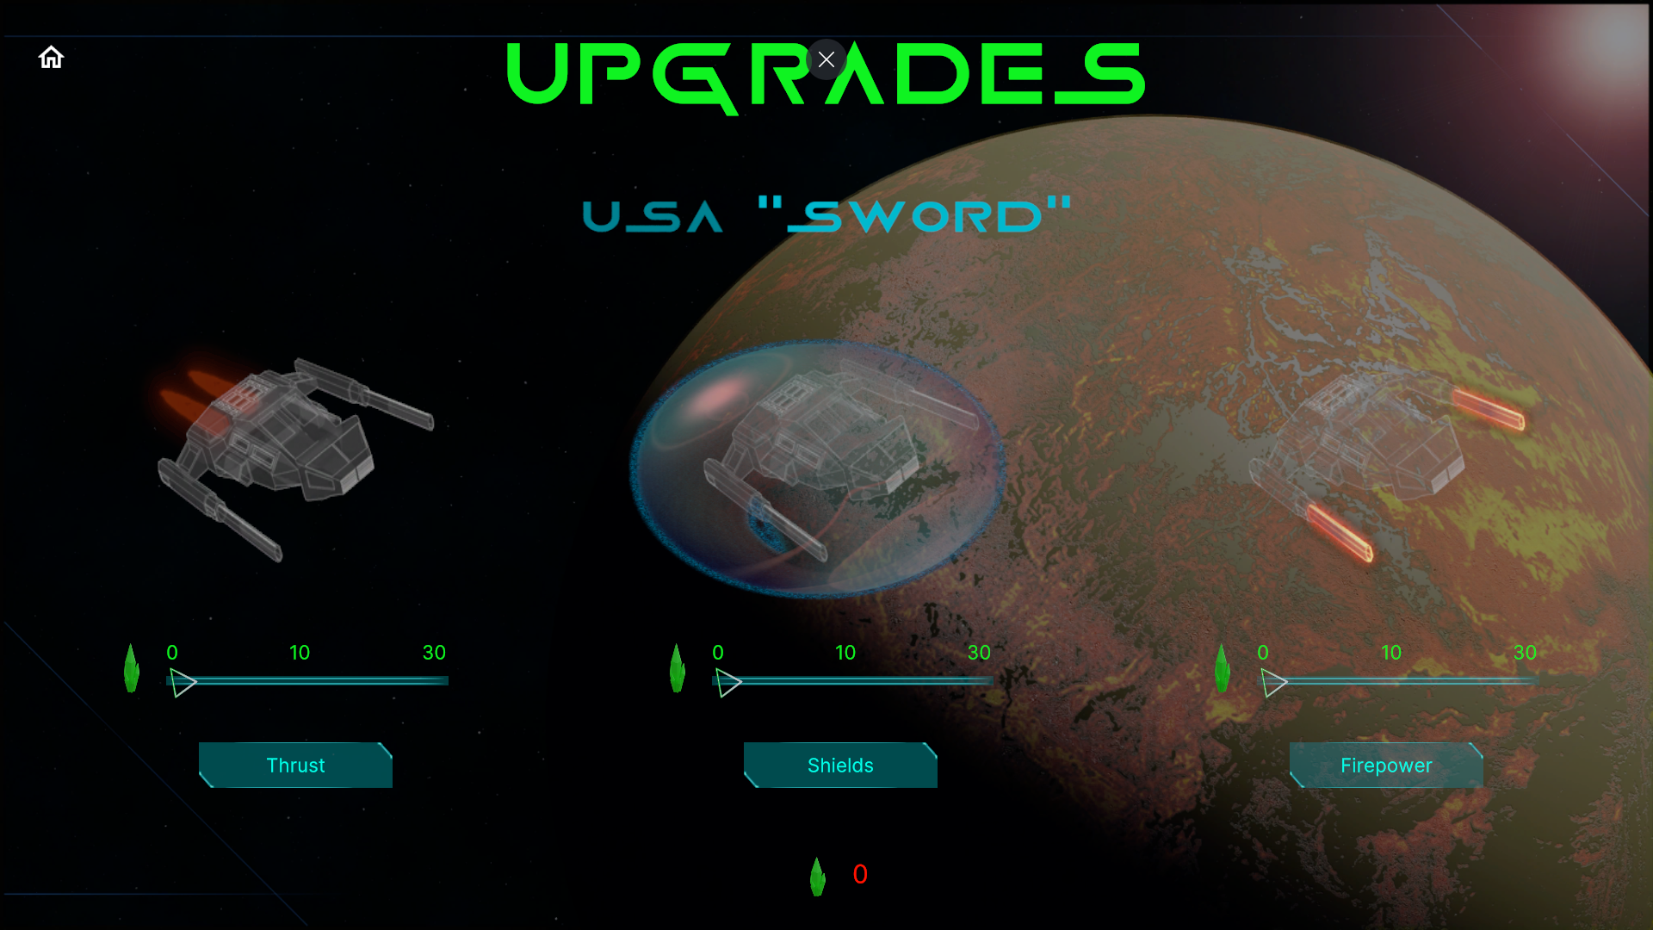

### High Score

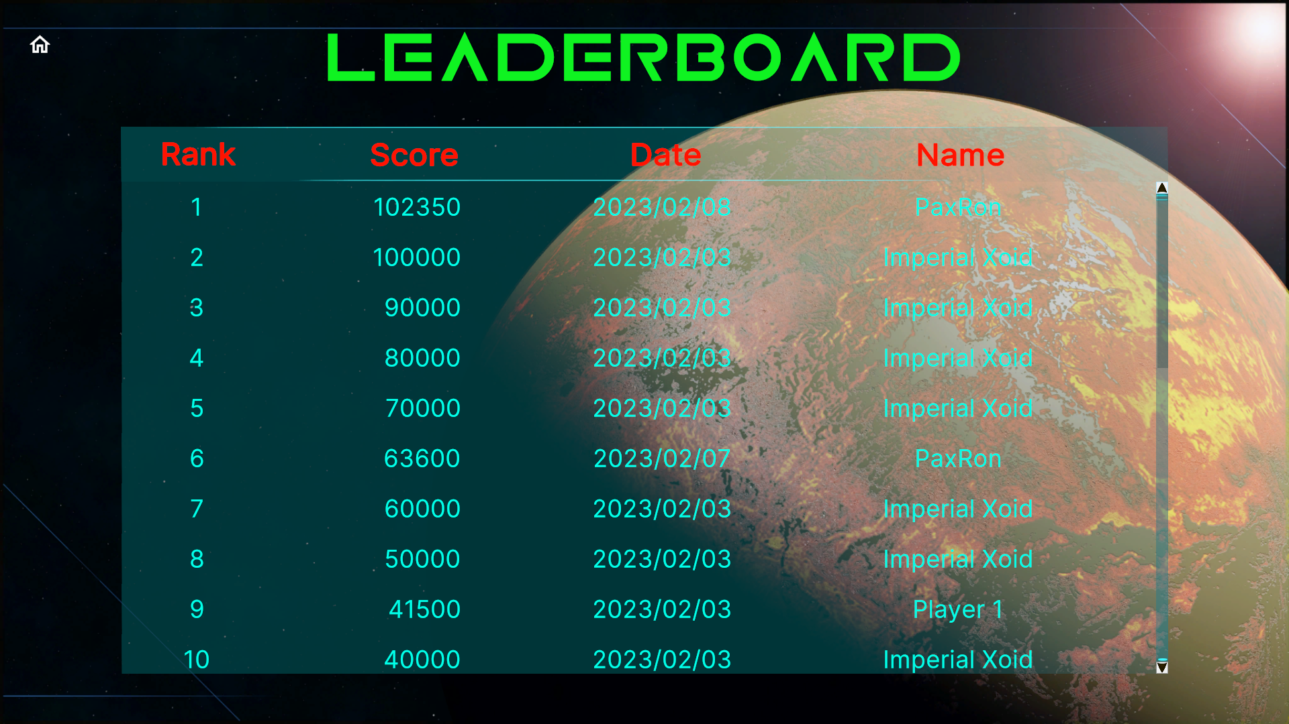

### Tutorial

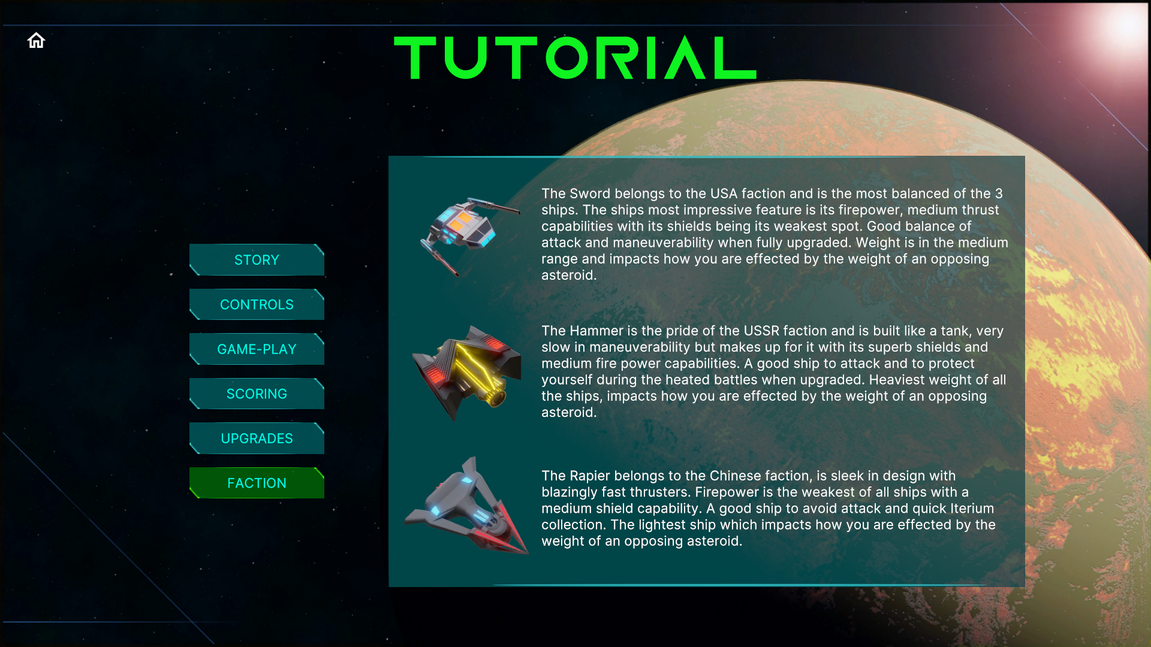

### Player Profile

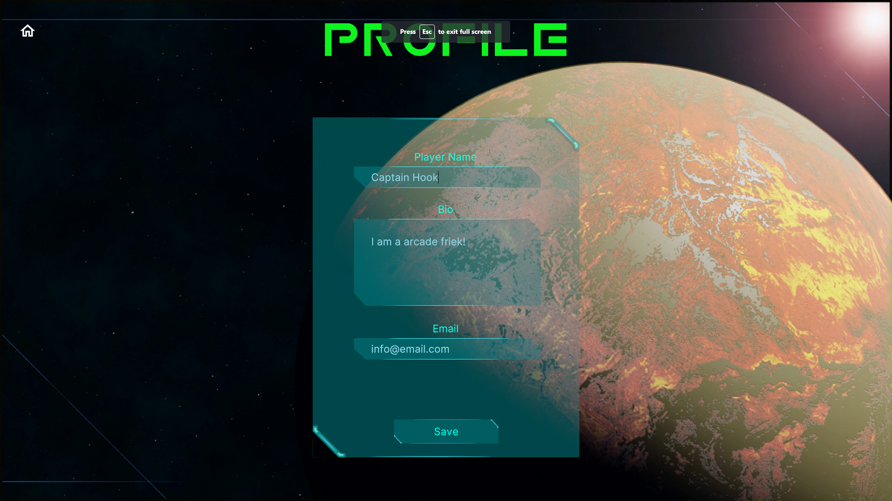

### Settings

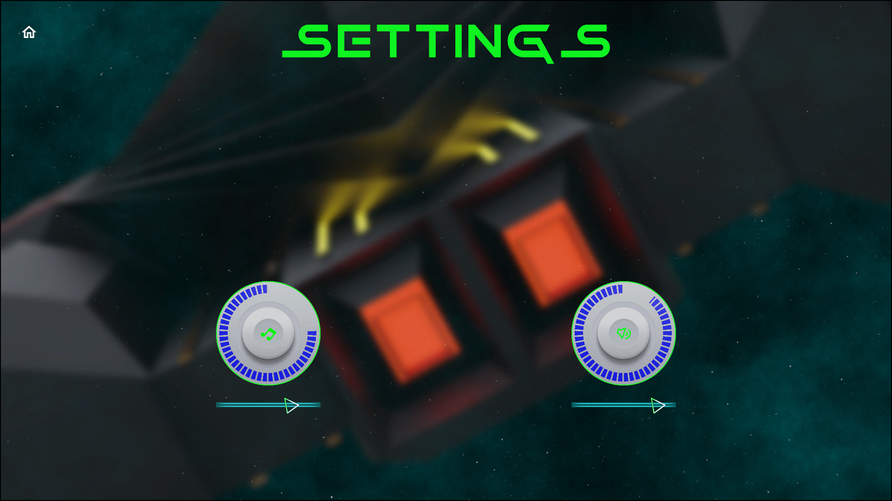

### Game Over

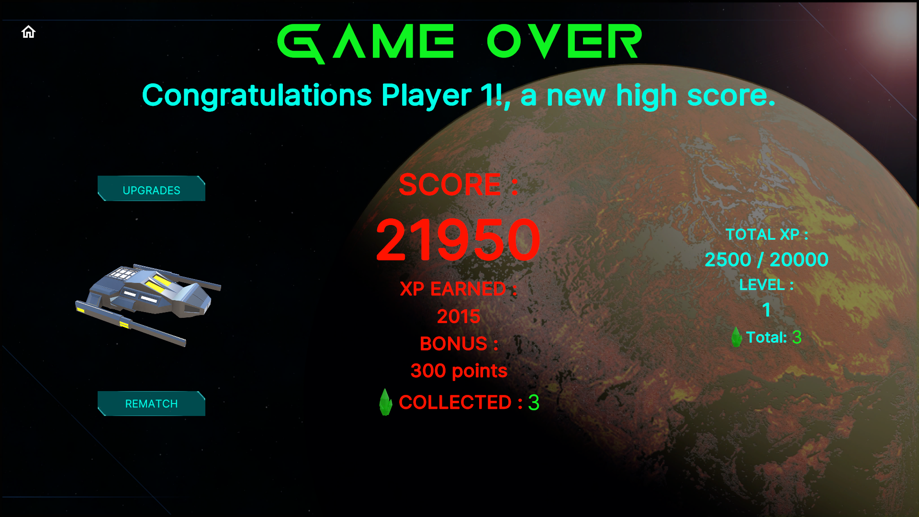

# Unity Project

## Project requirements

* Unity version 2021.3.15f1
* Render Pipeline: URP 12.1.8
* Input System (new)
* UI Toolkit
* Timeline
* Shader Graph
* Build platform: WebGL

## Folder Structure

|  |  |
| --- | --- |
| **Assets path sub folders** | **Description** |
| 3DModels | Ship and asteroid models |
| 3Dmodels/Bullets | Bullet models |
| 3Dmodels/Crystal | Iterium crystal model |
| 3Dmodels/Environment | Planet model |
| 3Dmodels/Materials | All model materials |
| 3Dmodels/Textures | All model textures |
| Animations | Animator/timeline files |
| Fonts | Font files |
| Images | Sprites for UI |
| Plugins | WebGL.jslib JavaScript plugin |
| Prefabs | All prefabs |
| RenderTextures | RenderTextures used to display models and shader graph progress bars |
| Scenes | All Unity scenes |
| ScriptableObjects | Created assets that hold the data |
| ScriptableObjects/Bullets | 3 levels of bullets per faction, Xoid bullet |
| ScriptableObjects/Factions | Factions – China, USA, USSR and Xoid |
| ScriptableObjects/Common | Common data and lists |
| ScriptableObjects/Common/Faction Types | Faction and NPC types |
| ScriptableObjects/Common/Lists | Lists of GameObjects and factions |
| ScriptableObjects/Common/Sound | Lists of sound effects and music |
| ScriptableObjects/Players | Player and AI data, holds the selected faction character SO |
| ScriptableObjects/Ships | Ship data, hold the ship bullet SO. |
| Scripts/ | All C# scripts |
| Scripts/Characters | Player controllers, leaderboard, bullets, Iterium |
| Scripts/General | Utility script like rotating an object |
| Scripts/Interfaces | IDamage interface for character damage |
| Scripts/Managers | Game and sound managers, object pooling |
| Scripts/Save System | Save/load system |
| Scripts/ScriptableObjects | ScriptableObject scripts |
| Scripts/Spawning | Player/AI/NPC spawners and de-spawners |
| Scripts/UI | UI scene scripts (UI Toolkit) |
| Settings | URP render pipeline assets |
| Settings/Import | Assets import templates |
| Settings/Input System | Input system asset (New Input System) |
| Settings/Renderer | URP renderers |
| Settings/Sound | Sound/music mixer |
| ShaderGraphs | Custom shaders for ship thrust effects and radial progress bars for the UI (health/shields/firepower/speed) |
| Sounds | All audio files |
| Sounds/Effects | Sound effect files |
| Sounds/Music | Music files |
| UI | UI Toolkit files |
| UI/Documents | UI Toolkit Documents (UXML) |
| Styles | UI Toolkit styles (uss) |
| UI Toolkit | UI Toolkit themes |
| WebGL Templates | WebGL custom loader (HTML) |

## Classes & Assemblies

Most classes are in the Iterium namespace and form part of the Assembly-CSharp assembly, the Scripts/General folder contains a “General” assembly definition asset and the Scripts/ScriptableObjects folder contains an “SO” assembly definition asset.

|  |  |  |  |
| --- | --- | --- | --- |
| **Class Name** | **Description** | **Derived From** | **Assembly** |
| AIController | Controls AI movement, shielding, firing etc. Added dynamically to a ship prefab when AI is spawned | MonoBehaviour | Assembly-Csharp |
| Asteroid | Asteroid damage/splitting, de-spawn, Iterium drop. Added to the asteroid prefabs | MonoBehaviour | Assembly-Csharp |
| BossController | Controls boss movement and firing | MonoBehaviour | Assembly-Csharp |
| PlayerController | Controls player movement, shielding, firing etc. Added to all ship prefabs | MonoBehaviour | Assembly-Csharp |
| NPCController | Controls movement and firing for Xoid UFO. Added to the Zoid prefab | MonoBehaviour | Assembly-Csharp |
| BulletBase | Bullet base class, asteroid destruction, bullet explosions, Iterium drop etc. | MonoBehaviour | Assembly-Csharp |
| Bullet | Player bullet, collision detection. Added to all bullet prefabs | BulletBase | Assembly-Csharp |
| BulletAI | AI bullet, collision detection. Added to a bullet prefab dynamically by the AI bullet pool | BulletBase | Assembly-Csharp |
| BulletNpc | Xoid bullet, collision detection. Added to the Zoid_Bullet prefab. | BulletBase | Assembly-Csharp |
| Iterium | Collision detection for item collection. Added to the Iterium prefab | MonoBehaviour | Assembly-Csharp |
| SO_Leaderboard | List<LeaderboardItem> high score leaderboard | ScriptableObject | Assembly-Csharp |
| LeaderboardItem | Leaderboard item fields / row template |  | Assembly-Csharp |
| AsteroidPooling | Asteroid spawn/de-spawn object pooling. Added to the Scripts empty gameObject in the Play scene | MonoBehaviour | Assembly-Csharp |
| BulletPooling | Bullet spawn/de-spawn object pooling. Added to the Scripts empty gameObject in the Play scene | MonoBehaviour | Assembly-Csharp |
| ExplosionPooling | Explosion spawn/de-spawn object pooling. Added to the Scripts empty gameObject in the Play scene | MonoBehaviour | Assembly-Csharp |
| Singleton | Singleton<T> base class | MonoBehaviour | Assembly-Csharp |
| GameManager | Player/AI objects, save/load, xp/level calculation, game settings, leaderboard, etc. Added to the Manager prefab | Singleton<T> | Assembly-Csharp |
| SoundManager | Playing of sounds and music. Added to the Manager prefab | Singleton<T> | Assembly-Csharp |
| InputManager | Device input for fire, thrust, rotate, shield etc. Added to ship prefabs | MonoBehaviour | Assembly-Csharp |
| PlayMusic | Play sound effect by index from the SoundManager | MonoBehaviour | Assembly-Csharp |
| FileSaveHandler | Load/save serialized JSON data to a file, 3 save files for Player/AI/Leaderboard, object instantiated by the GameManager |  | Assembly-Csharp |
| SaveData | Player/AI save data fields, objects instantiated by GameManager |  | Assembly-Csharp |
| AISpawner | Spawn the AI prefab after a set time, added to the AISpawner gameObject in the Play scene under Spawners gameObject | MonoBehaviour | Assembly-Csharp |
| AsteroidSpawner | Spawn asteroid prefabs at set intervals, added to various gameObjects under the Spawners gameObject in the Play Scene | MonoBehaviour | Assembly-Csharp |
| DeSpawnExplosion | Release explosion after a set time, added to the Bullet_Explosion prefab | MonoBehaviour | Assembly-Csharp |
| GameOverSpawner | Spawn selected ship on the game over scene, added to the Spawner gameObject in the GameOver scene | MonoBehaviour | Assembly-Csharp |
| NPCSpawner | Spawn xoid UFO at set intervals, added to the NPCSpawner gameObject in the Play scene under Spawners gameObject | MonoBehaviour | Assembly-Csharp |
| PlayerSpawner | Spawn player prefab after a set time, added to the PlayerSpawner gameObject in the Play scene under Spawners gameObject | MonoBehaviour | Assembly-Csharp |
| UI_Button | Generic button script to load a scene | MonoBehaviour | Assembly-Csharp |
| UI_FactionSelection | UI for the faction selection scene | MonoBehaviour | Assembly-Csharp |
| UI_Game | UI for gameplay scene | MonoBehaviour | Assembly-Csharp |
| UI_GameOver | UI for game over scene | MonoBehaviour | Assembly-Csharp |
| UI_Leaderboard | UI for the leaderboard scene | MonoBehaviour | Assembly-Csharp |
| UI_LoadUpgradeScene | Button script to load the upgrade scene | MonoBehaviour | Assembly-Csharp |
| UI_Profile | UI for the player profile scene | MonoBehaviour | Assembly-Csharp |
| UI_QuitGame | Button script to quit the application | MonoBehaviour | Assembly-Csharp |
| UI_Settings | UI for the settings scene | MonoBehaviour | Assembly-Csharp |
| UI_Tutorial | UI for the tutorial scene | MonoBehaviour | Assembly-Csharp |
| UI_Upgrade | UI for the upgrade scenes | MonoBehaviour | Assembly-Csharp |
| CameraZoom | Zoom camera when starting the play scene | MonoBehaviour | General |
| PlaySFXDelay | Play a AudioSource with a delay | MonoBehaviour | General |
| Rotate | Rotate any GameObject, example asteroids | MonoBehaviour | General |
| SO_Bullet | Bullet data, speed, firepower, prefab | ScriptableObject | SO |
| SO_Faction | Faction data, SO_Ship, factionId | ScriptableObject | SO |
| SO_FactionList | List<SO_Faction> of factions | ScriptableObject | SO |
| SO_GameObjects | List<GameObject> asteroids, explosions, Iterium | ScriptableObject | SO |
| SO_NPC | NPC data, Xoid ship | ScriptableObject | SO |
| SO_Player | Player/AI data, score, xp, health, lives, upgrades, etc | ScriptableObject | SO |
| SO_SFX | List<AudioClip> sound effects | ScriptableObject | SO |
| SO_Ship | Ship data, bullet, speed, shield power, prefab, etc | ScriptableObject | SO |
| SO_Types | Generic types or categories | ScriptableObject | SO |

## Interfaces

|  |  |
| --- | --- |
| Interface | Function |
| IDamage | Contracts the Damage() method to characters that can be damaged, for example Player/AI/NPC/Boss. Usually this method will invoke an event that the GameManager subscribes to add score and XP to the attacker. |

## Save System

### Save files and methods

The system saves all data in 3 separate JSON files, namely Player.save, AI.save and Leaderboard.save. The file names can be changed in the GameManager inspector.

|  |  |
| --- | --- |
| GameManager Method() | Function |
| SaveGame | Save player and AI data to a JSON files |
| LoadGame | Load player and AI from a JSON files |
| SaveLeaderboard | Save leaderboard entries to a JSON file |
| LoadLeaderboard | Load leaderboard entries from a JSON file |

### Path

The save path is set as Application.persistentDataPath by passing the value to the FileSaveHandler constructor when the new object is created inside the GameManager Start() method.

### Player data

The SaveData class, contains all player data fields that are saved. Two objects are created from this class inside the GameManager and passed to the FileSaveHandler for saving…

|  |  |
| --- | --- |
| GameManager Object | Function |
| saveData | SaveData class object to store the Player data for saving to file |
| saveDataAi | SaveData class object to store the AI data for saving to file |

### Leaderboard data

The LeaderboardItem class contains the save data fields for each row in the leaderboard. ScriptableObject SO_Leaderboard contains a List<LeaderboardItem> that stores the leaderboard rows, this list is passed to the FileSaveHandler for saving.

|  |  |
| --- | --- |
| Object | Function |
| Leaderboard | ScriptableObject asset with a List<LeaderboardItem> used for storing the leaderboard items |
| leaderboard.Leaderboard | GameManager Leaderboard List<> instance that is passed to the FileSaveHandler for saving to the file |

### File save handler

The FileSaveHandler class writes the save data to text files in JSON format.

|  |  |
| --- | --- |
| Method() | Function |
| Load | Load Player and AI data from file |
| Save | Save Player and AI to file |
| LoadLeadboard<T> | Load the leaderboard from file, converts array to a leaderboard List<> before being returned |
| SaveLeaderboard<T> | Save the leaderboard to file, converts the leaderboard List<> to an array before saving |

The Unity JsonUtility does not serialize a List<> to JSON if it is the top node, the FileSaveHandler contains a JsonHelper class as a wrapper to wrap the leaderboard List<> inside a “Items” node. The List<> is cast to an array for serialization and cast back to a List<> before being returned by the FileSaveHandler to the GameManager.

|  |  |
| --- | --- |
| JsonHelper Method() | Function |
| FromJson<T> | De-serialised from JSON |
| ToJson<T> | Serialise to JSON |

## ScriptableObjects

To reduce memory, aid testing and provide a designer friendly approach, data is stored inside ScriptableObject assets, this includes runtime data. Runtime data is loaded from the game save when the game starts, and updated data is saved at certain points back to the game save.

As summery of the main ScriptableObject game structure, the Player SO holds the players data including faction, the Faction SO holds the ship, the Ship SO holds the bullet and Bullet SO holds the bullet types as the player upgrades.

### SO_Leaderboard

The leaderboard asset contains a list that stores the high score rows. This List<> object is created inside the GameManager and passed to the FileSaveHandler for a game save.

|  |  |
| --- | --- |
| Asset | Function |
| Leaderboard | List<LeaderboardItem> containing all the high score rows |

### SO_Player

3 Assets are created from this class that hold all the characters data – example health, level, upgrades, and faction.

|  |  |
| --- | --- |
| Asset | Function |
| Player | All Player character data |
| AI | All AI character data |
| Xoid | All NPC character data |

### SO_FactionList

Single asset contains a list of factions.

|  |  |
| --- | --- |
| Asset | Function |
| Factions | Holds 4 SO_Faction assets |

### SO_Faction

4 Faction assets that contain data about the faction, faction ID and the game can also retrieve the faction ship from this asset.

|  |  |
| --- | --- |
| Asset | Function |
| CharChina | All faction data, most importantly the faction ship |
| CharUSA | All faction data, most importantly the faction ship |
| CharUSSR | All faction data, most importantly the faction ship |
| CharXoid | All faction data, most importantly the faction ship |

### SO_Ship

4 Assets that contains data about thrust, turn speed, shield, prefab, and the game can retrieve the ships bullet data.

|  |  |
| --- | --- |
| Asset | Function |
| Hammer | USSR faction ship data, AI uses the same faction |
| Rapier | Chinese faction ship data, AI uses the same faction |
| Sword | USA faction ship data, AI uses the same faction |
| Xoid | NPC faction ship data |

### SO_Bullet

Contains bullet data like speed, firepower, and list of 3 bullet level prefabs.

|  |  |
| --- | --- |
| Asset | Function |
| Photon Shell Chn | Chinese faction bullet data and types |
| Plasma Ball Ussr | USSR faction bullet data and types |
| Rocket Us | USA faction bullet data and types |
| Xoid | NPC faction bullet data and types |

### SO_SFX

Contains a list of sound effects or music to play, has a method that returns a random clip.

|  |  |
| --- | --- |
| Asset | Function |
| AsteroidExplosions | Asteroid explosion sounds |
| Effects | Various sound effects, played by index |
| Music | Game music for menu, game play, high score etc |
| ShipExplosions | Ship explosion sound effects |



## Managers

### Singleton

Base class for all singleton managers, namely GameManager and SoundManager classes. These 2 manager scripts are attached to the Managers prefab and gets instantiated from the main menu scene and lives for the lifetime of the game.

### GameManager

The main class from where most game functions are managed – save/load game, Player/AI/NPC objects, leaderboard management, calculations for bonuses, XP, levels, upgrades etc.

|  |  |
| --- | --- |
| Exposed Property | Function |
| SaveFile | Name of the player game save file. |
| SaveFileAi | Name of the AI game save file. |
| SaveFileLeaderboard | Name of the leaderboard game save file. |
| Leaderboardsize | The number of rows the leaderboard can have. |
| Player | Player Scriptable Object for the game to access all player and faction data. |
| factions | List of all factions to assign a faction to a player when he selects a ship. |
| deathRespawnRate | Delay in seconds before a player or AI is re-spawned after death. |
| xpLevelSteps | XP to gain for the player to gain a new level. |
| maxLevel | The maximum number of achievable levels. |
| freeShip | Score needed to gain a free live, this only happens once per battle. |
| aiPlayer | The AI ScriptableObject for the game to access all AI data and faction data. |
| aiPermadeath | Does the AI have lives or continuously re-spawns which is the default. |
| npcPlayer | Xoid ScriptableObject for the game to access all NPC data. |
| minSpeedNpc | Minimum speed within the random range for NPC speed |
| maxSpeedNpc | Maximum speed within the random range for NPC speed |
| bossPlayer | Boss ScriptableObject asset that contains all the boss data |
| iterium | Iterium ScriptableObject contains the Iterium prefab |
| iteriumChance | Chance for a splitting asteroid to drop a Iterium crystal. Default = 20:1 |
| speedLevel1 | Number of Iterium need to upgrade speed to level 2. |
| speedLevel2 | Number of Iterium need to upgrade speed to level 3. |
| shieldLevel1 | Number of Iterium need to upgrade shield to level 2. |
| shieldLevel2 | Number of Iterium need to upgrade shield to level 3. |
| firepowerLevel1 | Number of Iterium need to upgrade firepower to level 2. |
| firepowerLevel2 | Number of Iterium need to upgrade firepower to level 3. |
| Leaderboard | Leaderboard ScriptableObject containing a list of leaderboard rows. |

|  |  |
| --- | --- |
| Private Property | Function |
| fileSaveHandler | Instance of the FileSaveHandlder class to serialize data objects to a JSON file. Data objects passed are saveData, saveDataAI and leaderboard.Leaderboard |
| currentAIFaction | Current AI faction index, used to check if a AI respawn if a different faction so the AI bullet pool can be cleared. See SelectAiPlayer() method |
| OpenURL | JavaScript function from the plugin to open a URL in the current tab |

|  |  |
| --- | --- |
| Hidden Public Property | Function |
| saveData | Instance of the FileSaveHandlder class to serialize data objects to a JSON file. Data objects passed are saveData, saveDataAI and leaderboard.Leaderboard |
| saveAIData | Current AI faction index, used to check if a AI respawn if a different faction so the AI bullet pool can be cleared. See SelectAiPlayer() method |
| playerSpawner | Position of the spawner for respawns, position passed to this property by the SpawnPlayer event |
| aiSpawner | Position of the spawner for respawns, position passed to this property by the SpawnAi event |
| upgradeChnScene | China upgrade scene name |
| upgradeUsScene | USA upgrade scene name |
| UpgradeUssrScene | USSR upgrade scene name |
| isPlaying | Bool if the player is playing a game, if true don’t spawn player/AI from the co-routines when player exits the play before they spawn. |
| targetPlayer | Holds the spawned player, used by AI/NPC controllers to use as a target |
| targetAi | Holds the spawned AI, used by Player/NPC controllers to use as a target |
| targetNpc | Holds the spawned NPC, used by Player/AI controllers to use as a target |

|  |  |
| --- | --- |
| Method() | Function |
| OnEnable | Subscribe to events   * PlayerDamage – invoked when player takes damage * AiDamage – invoked when AI takes damage * NpcDamage – invoked when NPC takes damage * AsteroidDamage – invoked when asteroid takes damage * DropIterium – invoked when asteroid drops a crystal * CollectedIterium – invoked when Player or AI collects a crystal * SpawnPlayer – invoked by PlayerSpawner when Play scene starts * SpawnAi – invoked by AISpawner when Play scene starts * SpawnNpc – invoked by NPCSpawner repeatably at intervals * SpawnBoss – invoked by the BossSpawner repeatably at intervals * BossDestroy – invoked by the BossController before it gets destroyed * BossDamage – Invoked by BossController when hit by a bullet |
| OnDisable | Un-subscribe from all events |
| BossSpawning | * Spawn boss prefab * Increase music pitch |
| BossDestroy | Reset music pitch to normal |
| BossDamage | Award either the Player or AI with score and XP for hitting the boss |
| NpcSpawning | * Called by the SpawnNpc event, gets passed the position of a randomly selected gameObject under the NPCSpawner prefab * Spawns the NPC at the position * Set the NPC target * Sets a random speed |
| PlayerSpawning | * Called from the SpawnPlayer event * Set the playerSpawner gameObject position passed from the SpawnPlayer event invoked by the PlayerSpawner prefab * Calls the SpawnPlayer() method to spawn the Player prefab |
| AiSpawning | * Called by the SpawnAi event * Set the aiSpawner gameObject position passed from the SpawnAi event invoked by the AISpawner prefab * Calls the SpawnAi() method to spawn the AI prefab |
| CollectIterium | Increase Player or AI score, XP and Iterium collected |
| PlayerDamage | Increase AI score and XP |
| AiDamage | Increase Player score and XP |
| DropIterium | Instantiate an Iterium crystal |
| NPC Damage | Increase Player or AI score, XP |
| AsteroidDamage | Increase Player or AI score, XP |
| Start | * Instantiate new FileSaveHandler object * Load a game save * Initialise event listeners for Player/AI bullet/shield/speed upgrades |
| SelectAiPlayer | Randomly select a faction for the AI at each spawn |
| ResetGame | Reset all data to game defaults |
| ResetArena | Reset player/AI score/health/lives/Iterium /XP for a new arena battle |
| spawnPlayer | Call co-routine to spawn player prefab |
| spawnAi | * Call SelectAIPlayer() to select a random faction * Call co-routine to spawn AI prefab |
| SpawnPlayerOverTime | IEnumerator to spawn player prefab with a set delay |
| SpawnAiOverTime | IEnumerator to spawn AI prefab with a set delay |
| RandomScreenPosition | Gets a random spawn position near a spawn point |
| CameraShake | Call co-routine to shake camera when player dies |
| Shake | IEnumerator to shake camera with time and magnitude |
| SaveGame | * Update SaveData object with values from the Player ScriptableObject asset * Update aiSaveData object with values from the AI ScriptableObject asset * Pass both objects to the fileSaveHandler.Save() method to serialise and save the data to a JSON file * Call SaveLeaderboard() to save the leaderboard |
| LoadGame | * Populate the SaveData object with the data loaded from the Player save file * Update the Player ScriptableObject asset with the SaveData data * Populate the aiSaveData object with the data loaded from the AI save file * Update the AI ScriptableObject asset with the aiSaveData data * Call LoadLeaderboard() to load the leaderboard * Assign the default faction to the player if this is a new game * Call UpgradeLevelSync to sync the loaded data to the upgrade levels for speed/shield/bullet |
| SaveLeaderboard | Pass the leaderboard.Leaderboard (ScriptableObject) property of the GameManager to the fileSaveHandler for saving to a JSON file |
| LoadLeaderboard | * Load the leaderboard data from file into the leaderboard.Leaderboard property (ScriptableObject) of the GameManager * Call InitLeaderboard() |
| InitLeaderboard | If there are no current leaderboard rows (new game) then create new rows by the leaderboardSize property with the Xoid faction, multiplying each row score by 10 000 |
| AddLeaderboardItem | Called from the GameOver scene to add the player or AI score to the leaderboard when a high score is achieved |
| SortLeaderboard | Sort the leaderboard by score by descending, for a high score the last row is always checked to see if the player scorer is higher |
| GameOver | Load the GameOver scene |
| SceneUpgrade | Load the appropriate upgrade screen depending on the player currently selected faction. |
| MainMenu | Load the MainMenu scene |
| OnApplicationQuit | * Call SaveGame() * If WebGL build load a specific webpage * Else Application.Quit() is called |
| CalculateXP | Calculate if a player or AI increases in level after gaining XP in the arena. Level steps are calculated on the xpLevelSteps property |
| CalculateIterium | Add Iterium collected in the arena to the player/AI total Iterium value |
| CalculatePlayerBonus | Calculate how much points bonus a player earns after an arena. player.IteriumCollected * 100 * player.Level |
| CalculateAiBonus | Calculate how much points bonus a AI earns after an arena.  aiPlayer.IteriumCollected * 100 * aiPlayer.Level |
| BulletLvlChanged | Keeps the Player object bullet upgrade values in sync with the current upgrade level |
| ShieldLvlChanged | Keeps the Player object shield upgrade values in sync with the current upgrade level |
| SpeedLvlChanged | Keeps the AI object speed upgrade values in sync with the current upgrade level |
| BulletLvlChangedAi | Keeps the Player object bullet upgrade values in sync with the current upgrade level |
| ShieldLvlChangedAi | Keeps the AI object shield upgrade values in sync with the current upgrade level |
| SpeedLvlChangedAi | Keeps the AI object speed upgrade values in sync with the current upgrade level |
| UpgradeLevelSync | Sync the loaded game save upgrade data to the game upgrade properties for the player and AI |

### SoundManager

Play sound effects and music, runtime creation of AudioSources, volume management.

|  |  |
| --- | --- |
| Exposed Property | Function |
| asteroidExplosion | ScriptableObject list of sound clips for asteroid explosions |
| shipExplosion | ScriptableObject list of sound clips for ship explosions |
| effects | ScriptableObject list of sound clips for sound effects |
| music | ScriptableObject list of sound clips for music |
| audioSourceNumber | Number of AudioSources to create dynamically for use by sound effects. Music has its own single dedicated AudioSource and is not included in this. |
| mixerMaster | Audio mixer group for the master |
| mixerMusic | Audio mixer group for music |
| mixerSfx | Audio mixer group for sound effects |

|  |  |
| --- | --- |
| Private Property | Function |
| audiosourceSfx[] | AudioSource array used in round robin for sound effects |
| audiosourceMusic | Single AudioSource used for music |

|  |  |
| --- | --- |
| Method() | Function |
| Start | Set the effects and music mixer volumes that are loaded from game save into the Player object when the game starts |
| Awake | * Init AudioSource array to be used as round robin for sound effects * Assign the sound effects mixer group to the above AudioSources * Init an AudioSource for music * Assign the music mixer group to the above AudioSource |
| PlayAsteroidExplosion | Play a random sound from the AsteroidExplosions ScriptableObject asset |
| PlayShipExplosion | Play a random sound from the ShipExplosions ScriptableObject List<AudioClip> |
| PlayEffect | Play a sound by index from the Effects ScriptableObject List<AudioClip> |
| PlayMusic | Play a music by index from the Music ScriptableObject List<AudioClip>, method has properties to loop, stop and delay the clip |
| GetAudioSourceSfx | Returns an available AudioSource from the audiosourceSfx[] array |

### Bullet Pooling

Bullets fired from the player, AI and NPC are object pooled to increase performance. The GameManager provides the bullet prefabs to spawn from the player, aiPlayer and npcPlayer objects, depending on the faction that is selected and the level of the bullet.

|  |  |
| --- | --- |
| Exposed Property | Function |
| capacity | Default pool capacity of bullets for the player |
| maxCapacity | Maximum pool capacity of bullets for the player |
| capacityAi | Default pool capacity of bullets for the AI |
| maxCapacityAi | Maximum pool capacity of bullets for the AI |
| capacityNpc | Default pool capacity of bullets for the NPC |
| maxCapacityNpc | Maximum pool capacity of bullets for the NPC |
| bulletPoolPlayer | Player bullet pool (static) |
| bulletPoolAi | AI bullet pool (static) |
| bulletPoolNpc | NPC bullet pool (static) |

|  |  |
| --- | --- |
| Method() | Function |
| Awake | * Init a new bulletPoolPlayer pool object * Init a new bulletPoolAi pool object * Init a new bulletPoolNpc pool object |
| PoolNew_Player | Return a new instantiated Player bullet taking the Player bullet level |
| PoolNew_Ai | Return a new instantiated AI bullet taking the AI bullet level |
| PoolNew_NPC | Return a new instantiated NPC bullet |
| PoolGet | Get a bullet from the pool |
| PoolReturn | Return a bullet back to the pool |
| PoolDestroy | Destroy a bullet in the pool |

### Asteroid Pooling

Asteroids are spawned from a pool to increase performance. Properties exposed in the inspector are as follows…

|  |  |
| --- | --- |
| Exposed Property | Function |
| capacity | Default pool capacity of spawned asteroids |
| maxCapacity | Maximum pool capacity of spawned asteroids |
| asteroids | Asteroids prefab to be spawned from the Asteroids ScriptableObject asset |
| asteroidPool | Asteroid pool (static) |

|  |  |
| --- | --- |
| Method() | Function |
| Awake | Init a new asteroidPool pool object |
| PoolNew | Return a new instantiated asteroid prefab |
| PoolGet | Get an asteroid from the pool |
| PoolReturn | Return an asteroid back to the pool |
| PoolDestroy | Destroy an asteroid in the pool |

### Explosion Pooling

Explosions are spawned from a pool to increase performance. Properties exposed in the inspector are as follows…

|  |  |
| --- | --- |
| Exposed Property | Function |
| capacity | Default pool capacity of explosions to spawn |
| maxCapacity | Maximum pool capacity of explosions to spawn |
| explosion | Explosion prefab to spawn |
| explosionPool | Explosions pool (static) |

|  |  |
| --- | --- |
| Method() | Function |
| Awake | Init a new explosionPool pool object |
| PoolNew | Return a new instantiated explosion prefab |
| PoolGet | Get an explosion from the pool |
| PoolReturn | Return an explosion back to the pool |
| PoolDestroy | Destroy an explosion in the pool |

### Input Manager

**InputManager class is the main class to use the InputSystem for all actions except the Pause action, this is actioned from the UI_Game class.**

|  |  |
| --- | --- |
| Exposed Property | Function |
| rotateInput | Vector2 to rotate the ship left or right |
| thrustInput | Vector2 to thrust the ship forward |
| isFire | Bool to know if the ship is firing |
| isShield | Bool to know if the ship is shielding |
| isWarping | Bool to know if the ship is warping |

|  |  |
| --- | --- |
| Private Property | Function |
| input | Object of the InputSystem |

|  |  |
| --- | --- |
| Method() | Function |
| OnEnable | * Create new InputSystem object * Enable the Player action map * Create input action events |
| OnDisable | Disable all input action events |
| Rotate | Update rotateInput property, Player controller reads this from its Update() method |
| Thrust | Update thrustInput property, Player controller reads this from its FixedUpdate() method |
| Fire | Update isFire property, Player controller reads this from its Update() method |
| Shield | Update isShield property, Player controller reads this from its Update() method |
| Warp | Update isWarping property, Player controller reads this from its Update() method |



### **Input Actions – Input System**

Single action map called “Player” with the following actions.

* Movement and firing
* Shield
* Thrust
* Warp
* Pause

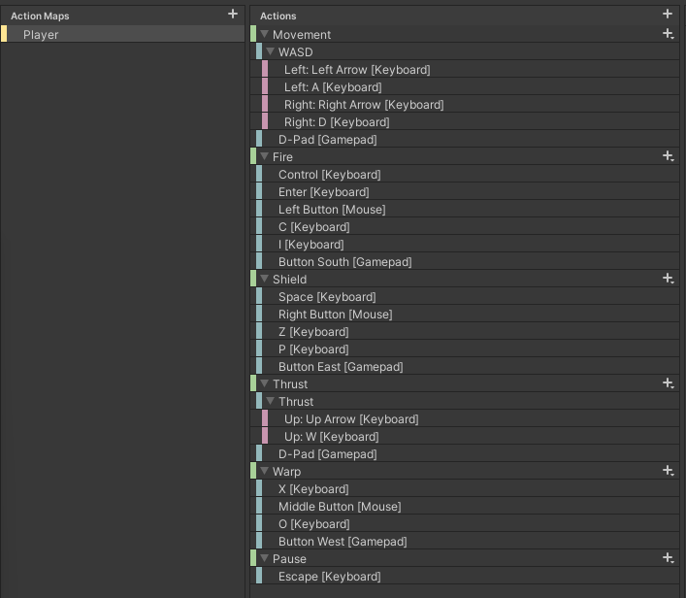



## Gameplay Scripts

Scripts that control character (player/AI/NPC) movement, firing, bullets, and Iterium collection etc.

### PlayerContoller

Control the player ship movement, thrusting, firing, shielding, warping and damage.

|  |  |
| --- | --- |
| Private Property | Function |
| input | InputManager component for input |
| firePosition | Empty GameObject on the ship from where bullets are spawned |
| shield | Plane with a Shader Graph material, gameObject is disabled at start, enabled when shielding |
| shieldCooldown | Used as a timer to limit when the player can deploy the shield |
| IsShielding | Bool to indicate if the ship is shielding to limit continuous shielding |
| thrusters | Plane with a Shader Graph material, gameObject is disabled at start, enabled when thrusting |
| isThrusting | Bool to indicate if the ship is thrusting to limit continuous thrusting |
| rigidBody | Used to add velocity to the ship |

|  |  |
| --- | --- |
| Medthod() | Function |
| Start | Get components for…   * input – InputManager for user input * shield – transform child under the ship at index 0, plane with a Shader Graph material to give a shield effect * thrusters – transform child under the ship at index 1, plane with Shader Graph material to display a thruster effect * firePosition – transform child under the ship at index 2, position from where the bullets will fire from * rigidBody – velocity is added from thrusting |
| Update | Calls methods to operate the player ship   * Rotate() * Fire() * Shield() * Warp() |
| FixedUpdate | Calls methods to move the ship   * Thrust() |
| Rotate | Rotation of the ship left or right, plus added turn speed with any upgrade bonus |
| Fire | Fire a bullet from the bullet pool, the velocity of the bullet is the factions ship speed plus any upgrade bonus |
| Thrust | * Thrusts the ship forward * Enables/disables the thrust effects – plane as child on the ship * Adds force to the rigidBody using the faction ships thrust plus any upgrade bonus |
| Shield | * Enables/disables the shield effects – plane as child on the ship * Play a sound from an AudioSource attached to the shield plane * Starts a co-routine ShieldTime() as a count-down timer * Start the shield cooldown so the player cannot deploy the shield again until the cooldown is finished |
| Warp | Warp the player to a random position near the player spawner |
| ShieldTime | IEnumerator that waits until the shield time is up and disables the shield |
| Damage | * Calculates damage using firepower and shield status * Destroys the ship if health is depleted * Invoke PlayerDamage event, pass the attacker in a string * GameManager subscribes and increases score and XP to attacker * Calls co-routine DestroyShip() if the health reaches zero |
| DestroyShip | IEnumerator to destroy the ship   * Instantiate 3 explosion effects from the explosions pool * Play the ship explosion sound effect from the SoundManager * Call the SpawnPlayer() method of the GameManager passing in the required delay time * Destroy the ship gameObject |
| OnBecameInvisible | When the ship leaves the screen it returns (wraps) the ship to the opposite side of the screen |

|  |  |
| --- | --- |
| Event | Function |
| PlayerDamage | * Event for when the Player takes damage |

|  |  |
| --- | --- |
| Interface | Function |
| IDamage | Contracts the Damage() method passing in bullet firepower and attacker |

### AIContoller

Control the AI ship movement, thrusting, firing, shielding and damage.

|  |  |
| --- | --- |
| Exposed Property | Function |
| fireDelay | Delay before the AI starts firing when spawning |
| fireInterval | Interval that the AI fires a bullet |
| warpInterval | How often does the AI decide warp or not |
| descisionCycle | How many shots are fired at a target before making another decision on who to target (Player or NPC) |

|  |  |
| --- | --- |
| Private Property | Function |
| firePosition | Empty GameObject on the ship from where bullets are spawned |
| shield | Plane with a Shader Graph material, gameObject is disabled at start, enabled when shielding |
| IsShielding | Bool to indicate if the ship is shielding to limit continuous shielding |
| thrusters | Plane with a Shader Graph material, gameObject is disabled at start, enabled when thrusting |
| isThrusting | Bool to indicate if the ship is thrusting to limit continuous thrusting |
| rigidBody | Used to add velocity to the ship |
| shots | How many shots have been fired to make a target decision if equal to the descisionCycle |
| attackNPC | Must the AI attack the NPC, 50/50 decision or the player could be dead |

|  |  |
| --- | --- |
| Medthod() | Function |
| Start | Get components for…   * shield – transform child under the ship at index 0, plane with a Shader Graph material to give a shield effect * thrusters – transform child under the ship at index 1, plane with Shader Graph material to display a thruster effect * firePosition – transform child under the ship at index 2, position from where the bullets will fire from * rigidBody – velocity is added from thrusting * InvokeRepeating for firing * InvokeRepeating for shielding, using the shield cooldown value as the interval |
| Update | Calls methods to operate the player ship   * Rotate() |
| FixedUpdate | Calls methods to move the ship   * Thrust() |
| Rotate | Rotation of ship to either target the Player or NPC |
| Fire | * Shoots a set number of bullets in a decision round, then decides again on its target, taking into account who is on the screen regards Player and NPC * Fire a bullet from the bullet pool, the velocity of the bullet is the factions ship speed plus any upgrade bonus |
| Thrust | * Thrusts the ship forward * Enables/disables the thrust effects – plane as child on the ship * Adds force to the rigidBody using the faction ships thrust plus any upgrade bonus |
| Shield | * Enables/disables the shield effects – plane as child on the ship |
| ShieldTime | IEnumerator that waits until the shield time is up and disables the shield |
| Warp | 50/50 descition to warp or not |
| Damage | * Calculates damage using firepower and shield status * Destroys the ship if health is depleted * Invoke AiDamage event, pass the attacker in a string * GameManager subscribes and increases score and XP to attacker |
| DestroyShip | IEnumerator to destroy the ship   * Instantiate 3 explosion effects from the explosions pool * Play the ship explosion sound effect from the SoundManager * Call the SpawnAi() method of the GameManager passing in the required delay time * Destroy the ship gameObject |
| OnBecameInvisible | When the ship leaves the screen it returns (wraps) the ship to the opposite side of the screen |

|  |  |
| --- | --- |
| Event | Function |
| AiDamage | * Event for when the AI takes damage |

|  |  |
| --- | --- |
| Interface | Function |
| IDamage | Contracts the Damage() method passing in bullet firepower and attacker |

### NPCContoller

Control the NPC ship (Xoid UFO) movement and firing.

|  |  |
| --- | --- |
| Exposed Property | Function |
| fireDelay | Delay before the NPC starts firing when spawning |
| fireInterval | Interval that the NPC fires a bullet |

|  |  |
| --- | --- |
| Private Property | Function |
| target | Random number to select the target of player or AI |

|  |  |
| --- | --- |
| Medthod() | Function |
| Start | InvokeRepeating for firing |
| Fire | Decides randomly on its target, considering who is on the screen regards Player and NPC |
| Damage | * Passes the attacker in a string * Invoked when the AI takes damage * GameManager subscribes and increases score and XP to attacker * Destroy ship |
| OnBecameInvisible | When the ship leaves the screen it gets destroyed |
| DestroyShip | Destroy the NPC gameObject |

|  |  |
| --- | --- |
| Event | Function |
| NpcDamage | * Event for when the NPC takes damage |

|  |  |
| --- | --- |
| Interface | Function |
| IDamage | Contracts the Damage() method passing in bullet firepower and attacker |



### BossController

Control the Boss ship (Xoid Mothership) movement and firing.

|  |  |
| --- | --- |
| Exposed Property | Function |
| minSpeed | Minimum random speed range |
| maxSpeed | Maximum random speed range |
| fireDelay | Delay before the Boss starts firing |
| fireInterval | Interval of firing |

|  |  |
| --- | --- |
| Private Property | Function |
| speed | Speed of the Boss – set by a random range between minSpeed & maxSpeed |
| target | Random number to select the target of player or AI |

|  |  |
| --- | --- |
| Medthod() | Function |
| Start | * InvokeRepeating for firing * Set random speed |
| Fire | Decides randomly on its target, considering who is on the screen regards Player and AI |
| Damage | * Passes the attacker in a string * Invoked when the Boss takes damage * GameManager subscribes and increases score and XP to attacker |
| OnBecameInvisible | When the ship leaves the screen it gets destroyed |
| DestroyShip | Destroy the Boss gameObject |

|  |  |
| --- | --- |
| Event | Function |
| BossDamage | Event for when the Boss takes damage, GameManager subscribes and awards score and XP to the attacker |
| BossDestroy | Event when the Boss is about to be destroyed, GameManager subscribes and reset the music pitch to normal |

|  |  |
| --- | --- |
| Interface | Function |
| IDamage | Contracts the Damage() method passing in bullet firepower and attacker |

### BulletBase

|  |  |
| --- | --- |
| Interface | Function |
| IDamage | Contracts the Damage() method passing in bullet firepower and attacker |

|  |  |
| --- | --- |
| Exposed Property | Function |
| minSpeed | Minimum range for random speed |
| maxSpeed | Maximum range for random speed |
| fireDelay | Delay before the boss starts shooting |
| fireInterval | Interval that bullets are fired |

|  |  |
| --- | --- |
| Method() | Function |
| Start | * Set random speed * InvokeRepeating fire |
| Update | Ship movement |
| Fire | Fire bullet, random decision to target Player or AI |
| Damage | Invoke BossDamage event, passing in the attacker. GameManager subscribes and increases the score and XP to the attacker |
| OnBecomeInvisible | * Invoke BossDestroy, GameManager subscribes and resets the increased music pitch back to normal * Call DestroyShip() |
| DestroyShip | Destroy the ship |

|  |  |
| --- | --- |
| Events | Function |
| BossDamage | Event that passes in the attacker. GameManager subscribes and increases the score and XP to the attacker |
| BossDestroy | GameManager subscribes and resets the increased music pitch back to normal |

### BulletBase

|  |  |
| --- | --- |
| Interface | Function |
| IDamage | Contracts the Damage() method passing in bullet firepower and attacker |

|  |  |
| --- | --- |
| Method() | Function |
| OnBecameInvisible | * Call ReleaseBullet() |
| Damage | Release bullet when it collides with an object |
| BulletExplosion | * Call bullet explosion sound from SoundManager * Instantiate an explosion visual effect from pool * Call ReleaseBullet() |
| ReleaseBullet | * Releases bullet back to pool, empty in the base class and is overwritten individually on each player/AI/NPC bullet |

### Bullet

Players bullet collision.

|  |  |
| --- | --- |
| Public Property | Function |
| firePower | Firepower of the bullet, value updated when the PlayerController instantiates |

|  |  |
| --- | --- |
| Method() | Function |
| OnTriggerEnter | * If IDamage interface contracted by PlayerController, then call the Damage() method * Do a bullet explosion |
| ReleaseBullet | * Release bullet to pool |

### BulletAI

AI bullet collision.

|  |  |
| --- | --- |
| Public Property | Function |
| firePower | Firepower of the bullet, value updated when the AiController instantiates |

|  |  |
| --- | --- |
| Method() | Function |
| OnTriggerEnter | * If IDamage interface contracted by AiController, then call the Damage() method * Do a bullet explosion |
| ReleaseBullet | * Release bullet to pool |

### BulletNpc

NPC bullet.

|  |  |
| --- | --- |
| Public Property | Function |
| firePower | Firepower of the bullet, value updated when the NPCController instantiates |

|  |  |
| --- | --- |
| Method() | Function |
| OnTriggerEnter | * If IDamage interface contracted by AiController, then call the Damage() method * Do a bullet explosion |
| ReleaseBullet | * Release bullet to pool |

### Iterium

Attached to a drop Iterium prefab, collection of the crystal by player or AI.

|  |  |
| --- | --- |
| Method() | Function |
| OnTriggerEnter | * invoke CollectIterium event passing who collected the crystal in a string |

|  |  |
| --- | --- |
| Event | Function |
| CollectIterium | * Passes attacker in a string * Invoked when the crystal is collected by Player or AI * GameManager subscribes to increase Iterium collected, score and XP |



### Asteroid

|  |  |
| --- | --- |
| Exposed Property | Function |
| IteriumChance | Chance of an Asteroid dropping a Iterium crystal when split |

|  |  |
| --- | --- |
| Method() | Function |
| Damage | * Splits and scales the Asteroid when hit by a bullet * Can be split 3 times into a random 2-4 pieces. * Asteroid weight is also adjusted according to the split size. * Chance to spawn an Iterium crystal * Release asteroid to pool |

|  |  |
| --- | --- |
| Event | Function |
| AsteroidDamage | * Passes the attacker in a string * Invoked when asteroid takes damage * GameManager subscribes to increase score and XP to the attacker |
| DropIterium | * Passes a Vector3 position of the asteroid * Invoked when an Iterium crystal is dropped * GamaManager subscribes to spawn the crystal at the position |



## User Interface

The only UI used is the project is the Unity Toolkit and the look and feel of the game can be changed through the Unity style sheets (uss).

### Unity Style Sheets

|  |  |
| --- | --- |
| ***MainStyle USS Classes*** | **Function** |
| *.button* | Buttons throughout UI |
| *.text* | Used across multiple UI documents to affect text’s |
| *.footer* | Footer text used in Main Screen |
| *.menu-button* | Home screen menu sprite |
| *.image-button* | Images on Faction Selection Screen |
| *.header* | Headers on all UI documents |
| *.text-score* | Leaderboard Item text |
| *.score-panels* | Leaderboard score panel adjustment |
| *.text-scoreHeading* | Leaderboard title headings |
| *.progress-slider* | Sliders in all documents |
| *.progress-slider-text* | Upgrade document slider text |
| *.button:hover* | Transitions for buttons on hover |
| *.button:active* | Transitions for buttons when active |
| *.button:focus* | Transitions for buttons when it has focus |
| *.unity-base-text-field__input* | Base input text fields |
| *.unity-base-field__input* | Base input text fields |
| *.unity-text-field__input* | Base input text fields |
| *.gridcontroller* | Tutorial document Control Panel alignments and spacing |
| *.ship-icon* | Tutorial document Scoring Panel ship sprites |
| *.controller-text* | Tutorial document text |
| *.unity-base-slider__dragger* | Sprite for slider handle |
| *.unity-base-slider__tracker* | Sprite for slider background |
| *.unity-scroller__slider* | Leaderboard scroller sprite |
| *.unity-scroller__low-button* | Image on vertical scrollbar for the Leaderboard scroll view |
| *.unity-scroller__high-button* | Image on vertical scrollbar for the Leaderboard scroll view |
| *#scrollViewHS .unity-scroller--vertical .unity-base-slider__dragger* | The scrollbar dragger image and background colour for the Leaderboard scroll view |

### UI Toolkit Documents

|  |  |
| --- | --- |
| UI Toolkit Documents | Function |
| FactionSelection | Used on the FactionSelection scene, contains 4 Render Textures in the UI for the Shader Graph progress bars of the 3 ships and the legend |
| GameOver | Used on the GameOver scene, contains 1 Render Texture to display the player ship |
| Leaderboard | Used on the Leaderboard scene, contains a scroll view named scrollViewHS |
| LeaderboardItem | Used as a row template inside the Leaderboard scrollViewHS |
| MainMenu | Used for the menu on the MainMenu scene |
| Play | Used to display the player/AI health, lives and Iterium collected, pause menu |
| Settings | Used on the Settings scene, contains 2 Render Textures to display the volume/effects radial shader graph progress bars. |
| Tutorial | Used on the Tutorial scene, various tutorial panels that are shown/hidden via script depending which tutorial button is clicked |
| UpgradeChina | Used on the UpgradeChina scene, has 3 sliders (thrust/shields/firepower) with a corresponding upgrade button, the sliders are disabled and are moved by a script when an upgrade is actioned. |
| UpgradeUSA | Used on the UpgradeUSA scene, has 3 sliders (thrust/shields/firepower) with a corresponding upgrade button, the sliders are disabled and are moved by a script when an upgrade is actioned. |
| UpgradeUSSR | Used on the UpgradeUSSR scene, has 3 sliders (thrust/shields/firepower) with a corresponding upgrade button, the sliders are disabled and are moved by a script when an upgrade is actioned. |
| UserProfile | Used on the UserProfile screen, various input boxes, the information is saved when the save button is clicked |

### UI Scripts

Refer to the Classes & Assemblies section for additional reference.

#### UI_Button

General button UI script to load a scene.

|  |  |
| --- | --- |
| Exposed Property | Description |
| sceneName | Holds the scene to load |
| buttonName | Button element – load the scene when clicked |

#### UI_FactionSelecton

FactionSelection scene UI script to allow the player to see the firepower/shield/speed stats of each ship and to select a shift for the arena.

|  |  |
| --- | --- |
| Exposed Property | Description |
| sceneName | Holds the Play scene to load |
| chinaFaction | Button element – Selects the China faction and updates the Player.Faction property of the GameManager |
| usaFaction | Button element – Selects the USA faction and updates the Player.Faction property of the GameManager |
| ussrFaction | Button element – Selects the USSR faction and updates the Player.Faction property of the GameManager |
| playerStatsText | Label element – Profile name of the player |
| playerXPTotal | Label element – Players total XP value |
| playerLevel | Label element – Players current level |
| playerIteriumTotal | Label element – Players total Iterium value |
| shipChn | Chinese ship ScriptableObject asset to get the ships base firepower/shield/speed |
| shipUs | USA ship ScriptableObject asset to get the ships base firepower/shield/speed |
| shipUssr | USSR ship ScriptableObject asset to get the ships base firepower/shield/speed |
| progressChnFirepower | Plane with Shader Graph material, China firepower radial progress bar, set float on the progress bar material (“_RemovedSeg”) |
| progressChnSpeed | Plane with Shader Graph material, China speed radial progress bar, set float on the progress bar material (“_RemovedSeg”) |
| progressChnShield | Plane with Shader Graph material, China shield radial progress bar, set float on the progress bar material (“_RemovedSeg”) |
| progressUsFirepower | Plane with Shader Graph material, US firepower radial progress bar, set float on the progress bar material (“_RemovedSeg”) |
| progressUsSpeed | Plane with Shader Graph material, US speed radial progress bar, set float on the progress bar material (“_RemovedSeg”) |
| progressUsShield | Plane with Shader Graph material, US shield radial progress bar, set float on the progress bar material (“_RemovedSeg”) |
| progressUssrFirepower | Plane with Shader Graph material, USSR firepower radial progress bar, set float on the progress bar material (“_RemovedSeg”) |
| progressUssrSpeed | Plane with Shader Graph material, USSR speed radial progress bar, set float on the progress bar material (“_RemovedSeg”) |
| progressUssrShield | Plane with Shader Graph material, USSR shield radial progress bar, set float on the progress bar material (“_RemovedSeg”) |

#### UI_Game

Game scene UI script to display the health/Iterium collected, and lives of the player/AI.

|  |  |
| --- | --- |
| Exposed Property | Description |
| sceneName | Holds the MainMenu scene to load |
| player1 | TextElement to display player profile name |
| scorePlayer1 | TextElement to display player score |
| iteriumPlayer1 | TextElement to display the player stage collected Iterium |
| player2 | TextElement to display AI profile name |
| scorePlayer2 | TextElement to display AI score |
| iteriumPlayer2 | TextElement to display the AI stage collected Iterium |
| ship1Player1 | VisualElement to display the player 1st ship life image |
| ship2Player1 | VisualElement to display the player 2nd ship life image |
| ship3Player1 | VisualElement to display the player 3rd ship life image |
| ship4Player1 | VisualElement to display the player 4th (extra life) ship life image |
| ship1Player2 | VisualElement to display the AI 1st ship life image |
| ship2Player2 | VisualElement to display the AI 2nd ship life image |
| ship2Player2 | VisualElement to display the AI 3rd ship life image |
| progressPlayerHealth | Plane with Shader Graph material, player radial health progress bar, set float on the progress bar material (“_RemovedSeg”) |
| progressAiHealth | Plane with Shader Graph material, AI radial health progress bar, set float on the progress bar material (“_RemovedSeg”) |
| pause | VisualElement – pause panel with 2 buttons |
| exitGame | Button element – pause button to exit the stage and return to MainMenu scene |
| continueGame | Button element – pause button to close pause panel and continue stage |

#### UI_GameOver

Game Over scene UI script, displays the users arena score, collected XP, Iteruim, high score music, custom message based on how good the score is.

|  |  |
| --- | --- |
| Exposed Property | Description |
| gameScene | Holds the Play scene to load |
| playerScore | Label to display player stage score |
| playerIterium | Label to display player stage collected Iterium |
| playerIteriumTotal | Label to display player total Iterium |
| message | Label to display custom score related congratulations message |
| rematch | Button element to re-start the Play scene |
| playerXPTotal | Label to display player total XP |
| playerXPEraned | Label to display player stage XP |
| playerLevel | Label to display player level, level progression is calculated in this scene |
| playerBonus | Label to display player stage score bonus, (Iterium collected x 100) x level |

#### UI_Leaderboard

Leaderboard scene UI script to display the top player/AI high scores by score ranking

|  |  |
| --- | --- |
| Exposed Property | Description |
| scoreRow | VisualTreeAsset – leaderboard row document template |
| rank | Label to display leaderboard item ranking |
| score | Label to display leaderboard item score |
| date | Label to display leaderboard item date |
| playerName | Label to display player name |

#### UI_LoadUpgradeScene

Loads the appropriate faction upgrade scene depending on the players currently selected faction.

|  |  |
| --- | --- |
| Exposed Property | Description |
| upgradeButton | Button element to ask the GameManger to load the upgrade scene of the player selected faction |

#### UI_Profile

PlayerProfile scene UI script, display and save input for player name, bio and email address.

|  |  |
| --- | --- |
| Exposed Property | Description |
| sceneName | Holds the MainMenu scene to load |
| playerName | TextField input for the player name |
| bio | TextField input for the player bio description |
| email | TextField input for the player email address |
| save | Button element to save input field data and load the MainMenu scene |

#### UI_QuitGame

Attached to the quit button to call the Game Manager OnApplicationQuit() method, which saves the games and redirects to a chosen webpage.

|  |  |
| --- | --- |
| Exposed Property | Description |
| buttonName | Button element to exit the game |

#### UI_Settings

Settings scene UI script to display the current music and sound effects volumes, adjusts the volumes when the appropriate sliders are changed.

|  |  |
| --- | --- |
| Exposed Property | Description |
| musicSlider | Slider element to change the music volume |
| soundslider | Slider element to change the sound effects volume |
| musicIcon | VisualElement to rotate the music icon image |
| soundIcon | VisualElement to rotate the sound effects icon image |
| progressMusic | Plane with Shader Graph material, music radial progress bar, set the float on the progress bar material (“_RemovedSeg”) |
| progressSound | Plane with Shader Graph material, sound effects radial progress bar, set the float on the progress bar material (“_RemovedSeg”) |
| audioMixer | Sound Audio Mixer asset to set the volume of the music float (“Music”) and sound effects float (“Sound”) |

#### UI_Tutorial

Tutorial scene UI scripts to hide/show tutorial VisualElements depending on what tutorial buttons are selected.

|  |  |
| --- | --- |
| Exposed Property | Description |
| buttonStory | Button element to show the story tutorial panel |
| controls | Button element to show the controls tutorial panel |
| gameplay | Button element to show the gameplay tutorial panel |
| scoring | Button element to show the scoring tutorial panel |
| upgrades | Button element to show the upgrades tutorial panel |
| faction | Button element to show the factions tutorial panel |
| storyPanel | VisualElement of the story panel |
| controlsPanel | VisualElement of the controls panel |
| gameplayPanel | VisualElement of the gameplay panel |
| scoringPanel | VisualElement of the scoring panel |
| upgradesPanel | VisualElement of the upgrades panel |
| factionPanel | VisualElement factions panel |

#### UI_Upgrade

Faction upgrade scene, upgrades the ships firepower, speed and shield if the player has the required Iterium.

|  |  |
| --- | --- |
| Exposed Propertt | Description |
| thrustSlider | Slider element to indicate the current thrust upgrade |
| shieldSlider | Slider element to indicate the current shield upgrade |
| firePowerSlider | Slider element to indicate the current firepower upgrade |
| thrustUpgrade | Button element to upgrade the thrust if the player has the indicated Iterium |
| shieldUpgrade | Button element to upgrade the shield if the player has the indicated Iterium |
| firepowerUpgrade | Button element to upgrade the firepower if the player has the indicated Iterium |
| iteriumAmount | Label element to indicate the player total Iterium |
| thrustLevel1 | Label element to show the required Iterium needed for the thrust level 1, set in the GameManager class |
| thrustLevel2 | Label element to show the required Iterium needed for the thrust level 2, set in the GameManager class |
| shieldLevel1 | Label element to show the required Iterium needed for the shield level 1, set in the GameManager class |
| shieldLevel2 | Label element to show the required Iterium needed for the shield level 2, set in the GameManager class |
| firepowerLevel1 | Label element to show the required Iterium needed for the firepower level 1, set in the GameManager class |
| firepowerLevel2 | Label element to show the required Iterium needed for the firepower level 2, set in the GameManager class |



## Spawning

The spawning folder holds all the spawning scripts, these are attached to an empty prefab and placed where you want the player/AI/NPC to spawn. The asteroids have 4 empty gameObject spawners in the scene and a target object where they point to when spawned.

|  |  |
| --- | --- |
| Script Name | Description |
| PlayerSpawner | Invokes a SpawnPlayer event passing in the spawner position and delay time. GameManager subscribes to the event and spawns the player |
| AISpawner | Invokes a SpawnAi event passing in the spawner position and delay time. GameManager subscribes to the event and spawns the AI |
| NPCSpawner | Invokes the SpawnNpc event periodically, and passes the position of a randomly selected gameObject under the NPCSpawner prefab |
| AsteroidSpawner | This script is attached to 4 empty gameObjects in the scene, but more can be added, and move towards a target gameObject (AsteroidTarget). A random speed is selected and the AsteroidPooling class selects a random prefab to spawn.     * spawnInterval property is the time before each spawn * minSpeed is the min range of the random speed selection * maxSpeed is the max range of the random speed selection * spawnOnceOnly allows only 1 asteroid to spawn * target is the AsteroidTarget game object that the asteroid moves towards |
| BossSpawner | Periodically invokes the SpawnBoss event, GameManager subscribes to spawn the boss. |
| DeSpawnAsteroid | Releases the asteroid back to the pool when the asteroid leaves the camera view |
| DeSpawnExplosion | Releases the explosion effect back to the pool after a set time delay |
| GameOverSpawner | Spawn the players currently selected ship on the Game Over scene. |



## Plugins

WebGL.jslib plugin file in the Plugins folder for various JavaScript methods.

|  |  |
| --- | --- |
| Functions | Description |
| syncSave | Force update of IndexedDB immediately when actioning a save game, otherwise the browser session will not save the data immediately |
| alert | Alert popup to display a message to the user or debugging, used in the FileSaveHandler for error alerts |
| OpenURL | Opens a web URL in the current tab, used to visit another website when the exit button is clicked |



## Builds

Build settings platform must be set to WebGL

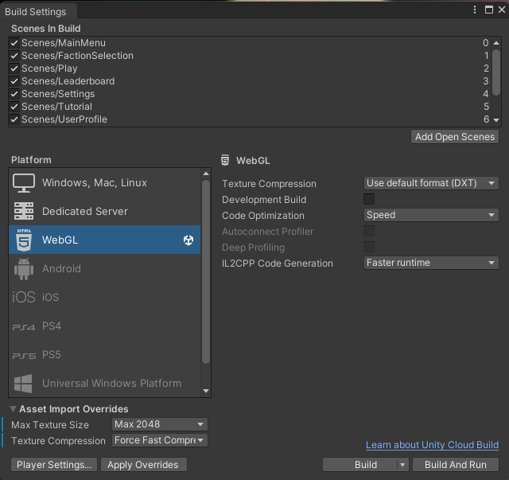

Change the background, game and studio logos for the splash page under Player Settings.

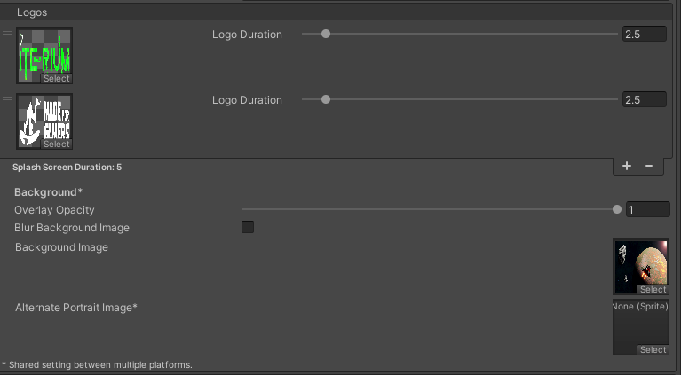

Also, under Player Settings / Publishing Settings, change the compression accommodated by your web server, depending on the server OS and web server you may need to include an appropriate config file for the compression and handling of the wasm files and mime types such as .mem and .data.

See Unity documentation here on web server config files - [Link](https://docs.unity3d.com/Manual/webgl-server-configuration-code-samples.html)  
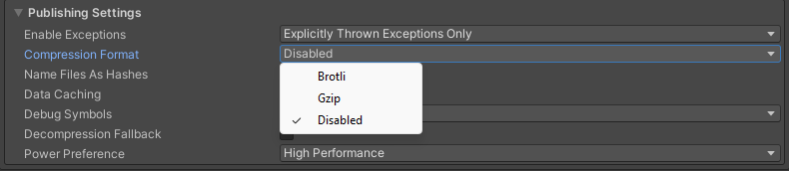

You can change the HTML loading template under the folder WebGL Templates / MFG

Finally build the project and copy the build folder contents to your web server, open the URL to the website in your browser, sometimes you would have to add the Index.html (case sensitive) at the end of the URL, for example the GitHub Pages hosting environment.